|  |  |  |
| --- | --- | --- |
| **Name: Sumukh Raju Bhat** | **SRN: PES1UG19CS519** | **Date: 28/04/2022** |
| **Section: H** | **OOAD Assignment** |

**CLASS DIAGRAM:**

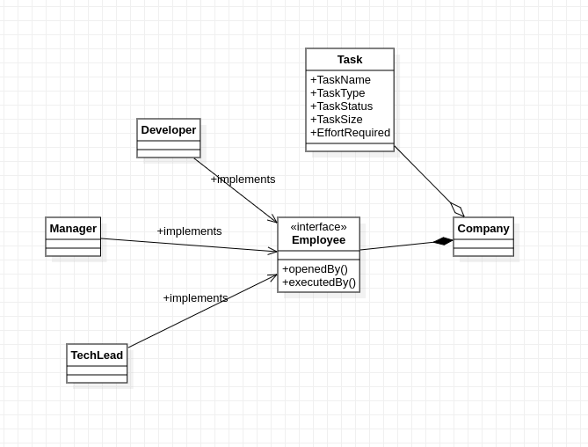

**Design pattern information:**

Creation pattern:

1. Factory :

The employee interface serves as a common ground, allowing the firm to add more categories of employees in addition to developer, techlead, and manager without having to change the base class.

Behavioral pattern:

1. Chain of responsibility :

The request is passed from the employee to the task object.

1. State:

Depending on which employee is allocated to the task, the status of the task object varies.

**Output Screen Shot:**

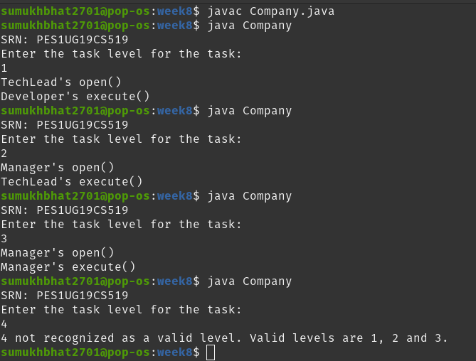

**Code:**

1. Company.java

// SRN: PES1UG19CS519

import java.util.Scanner;

public class Company{

public static void main(String[] args)

{

Scanner sc = new Scanner(System.in);

int level;

System.out.println("SRN: PES1UG19CS519");

System.out.println("Enter the task level for the task:");

level = sc.nextInt();

sc.close();

Task task = new Task("Tester", "High", "Started", level, "Easy", "1 day");

Employee techLead = new TechLead();

Employee developer = new Developer();

Employee manager = new Manager();

if(task.taskLevel==1)

{

task.openedBy(techLead);

task.executedBy(developer);

}

else if(task.taskLevel==2)

{

task.openedBy(manager);

task.executedBy(techLead);

}

else if(task.taskLevel==3)

{

task.openedBy(manager);

task.executedBy(manager);

}

else

{

System.out.println(level + " not recognized as a valid level. Valid levels are 1, 2 and 3.");

}

}

}

1. Task.java

// SRN: PES1UG19CS519

public class Task {

String taskName;

String taskType;

String taskStatus;

int taskLevel;

String taskSize;

String effortRequired;

public Task()

{

taskName = "default-task";

taskType = "default-task-type";

taskStatus = "default-task-status";

taskLevel = 1;

taskSize = "default-task-size";

effortRequired = "0 day";

}

public Task(String taskName, String taskType, String taskStatus, int taskLevel, String taskSize, String effortRequired) {

this.taskName = taskName;

this.taskType = taskType;

this.taskStatus = taskStatus;

this.taskLevel = taskLevel;

this.taskSize = taskSize;

this.effortRequired = effortRequired;

}

public void executedBy(Employee employee) {

employee.executedBy();

}

public void openedBy(Employee employee) {

employee.openedBy();

}

}

1. Employee.java

// SRN: PES1UG19CS519

public interface Employee{

public void openedBy();

public void executedBy();

}

1. Manager.java

// SRN: PES1UG19CS519

public class Manager implements Employee{

public void openedBy() {

System.out.println("Manager's open()");

}

public void executedBy() {

System.out.println("Manager's execute()");

}

}

1. Developer.java

// SRN: PES1UG19CS519

public class Developer implements Employee {

public void openedBy() {

System.out.println("Developer's open()");

}

public void executedBy() {

System.out.println("Developer's execute()");

}

}

1. TechLead.java

// SRN: PES1UG19CS519

public class TechLead implements Employee {

public void openedBy() {

System.out.println("TechLead's open()");

}

public void executedBy() {

System.out.println("TechLead's execute()");

}

}